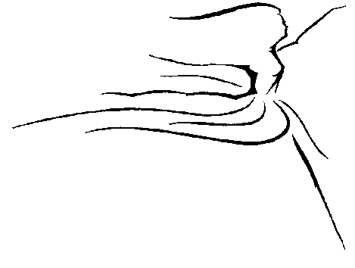
Abigail Francisco

School of Classical Ballet

HOLIDAY FANTASTIC AUDTION REGISTRATION

STUDENT: _____________________________________________________________________________
Last First Middle

MAILING ADDRESS: ___________________________________________________________________
Street City State Zip

E-mail address (parents’ e-mail): ____________________________________________________________

Additional e-mail address: _____________________________________________________________

HOME PHONE: ___________________________ Date of Birth: ______________ Age: ________

FATHER: _____________________Cell #:_____________________ Work #:____________________

MOTHER: ____________________Cell #:_____________________ Work #:____________________

Waiver and Release from Liability

I, __________________________________________________, recognize that dance is a physical art and injuries may occur, yet I do
Parent/Guardian if participant is under 18 years of age - Print Name

hereby release and forever discharge the Abigail Francisco School of Classical Ballet, LLC, its agents, its employees, instructors and representatives from all claims, demands or claims for relief which may arise from or relate to any and all injury from participation in dance at the Abigail Francisco School of Classical Ballet, LLC. This shall include, but not be limited to, any and all activities in the dance school, directly or indirectly around the dance school, or in any other place so designated by the Abigail Francisco School of Classical Ballet, LLC including performances and other activities. Further, I understand that in the instruction of dance and in particular, ballet, the touching of the student by the instructor may occasionally occur. This touching will occur only in assisting the student in the proper alignment and execution of dance steps. I hereby authorize the dance instructors to so touch myself or my child in an APPROPRIATE fashion, in order to assist myself or my child.

I understand that video cameras are installed in the studio to ensure the safety and well being of myself and/or my child. The information contained on these tapes will be secure and accessible by authorized personnel only.

I have read this document and fully agree and understand that it is a release of all claims. In an emergency situation, I hereby grant permission for a staff member at the Abigail Francisco School of Classical Ballet, LLC, to seek emergency medical treatment for my child or myself.

_____________________________________________________ ______________________________________________
Signature Date

